SUPERLUXE & Partners sign
Exclusive Fine Art Partnership with Antonio Russo Art (aka STONY)

SUPERLUXE & Partners, a Jersey-based Global Art Representation business has today, 22nd January 2025, signed an Exclusive Art Partnership Agreement with Antonio Russo Art, aka STONY, an award-winning Artist, that sees SUPERLUXE bring a Collection of 10 STONY artworks exclusively to the global Fine Art Print and Digital Art market.

STONY, best known for his expressive street art, has agreed that a unique collection of 10 artworks can be offered by SUPERLUXE & Partners as Limited Edition prints, 1/1 Originals, and printed on SUPERLUXE’s exclusive Glass ‘Curtisium AROI’ glass.

The ‘STONY’ Collection by SUPERLUXE forms a multi-million pound fine art offering for Antonio Russo Art & The Stony Foundatin exclusively by SUPERLUXE and will offer early collectors and investors a unique opportunity to acquire an artwork before the price increases. All formats will be marketed, sold and fulfilled through the SUPERLUXE.IO Fine Art Platform, launching very soon.

Speaking about the Art Partnership, Oscar Russo, son of the late Antonio Russo said “Our collaboration with SUPERLUXE is really exciting. Building my father’s legacy globally and collaborating with partners like SUPERLUXE will continue to get his works out there. James’ vision for fine art is unique and the approach they are taking is so different to the collaborations we have done previously.”

James A Matthewson, Founder & CEO at SUPERLUXE & Partners, also commented saying that “We (SUPERLUXE) sold 10 STONY Originals two years ago and loved his work so much. It’s wonderful that, two years on, we have now signed this Partnership Agreement and will bring this Collection to market globally. We can’t wait to show the Collection to the world.”

SUPERLUXE & Partners (Jersey) and SUPERLUXE.io (BVI) is led by James A Matthewson, who brings 20+ years experience of working with some of the most prestigious luxury brands from across the globe.

James can be contacted on +44 7797 777507 or james@superluxe.art and will help Art Collectors and Investors with the purchase of their STONY fine art from SUPERLUXE.

Notes to Editors:
Date of Release: 22nd January 2025
Contact: James A Matthewson +44 7797 777507 / james@superluxe.art
Website: superluxe.io

About STONY / Antonio Russo

‘’This is my life, my story, my book. I will no longer let anyone else write it’’.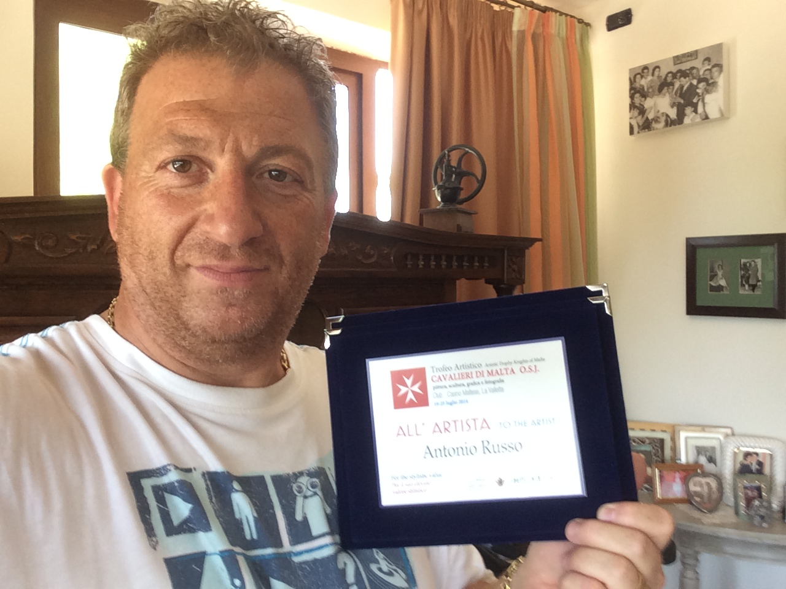
Stony’s expressive street art comes from the creative mind of a truly passionate artist who paints his ‘diary on canvas’ and strongly presents art at its absolute rawest form.
Stony was born in England in 1965. As both his parents were Sicilian, he was taken back to Sicily and spent his early years living in a town called Ribera, Southern Sicily.
Stony began painting and drawing at a very young age. Being heavily dyslexic and autistic, he always found difficulty in expressing himself. He has always used art as his expression tool. He used his built up energy to create detailed pencil drawings of both the surrounding landscapes, but also similar in style to the paintings he creates now.
Stony moved back to the UK with his sister when he was 12, not being able to speak the language. He struggled at school, being heavily dyslexic but also was bullied for many years.
His Father, Antonino Russo, was a Sicilian orphan that came to England on a sail boat when he was 14 to find work. He came with only the clothes on his back.
After many years of hard work, his Dad was a very successful business man, owning his own restaurant chain, being one of the biggest fruit and veg importers in Europe, alongside many other businesses. He was known as the ‘Italian Del Boy’.
Stony, watching his dad create a great and successful business empire from nothing, got a lot of his motivation and inspiration from him, as well as a lot of drive and determination from being bullied at school-
Age of 16 he was racing carts. At the age of 18 he was racing cars in ‘Formula Ford’.
At the age of 21 he was racing cars in ‘Formula Three’ with names like Damon Hill, Eddie Irvine, Johnny Herbert, Mark Blundell, and Paul Warwick.
His racing career came to an immediate stop when he was 23 after had a huge accident which left him in a coma and with serve back injury.
Unable to race again, Stony did the only thing he knew how, after watching his Father for many years, he opened a restaurant. By the time he was 26, he had a chain of 8 restaurants up and down the country.
When he was 28 he declared bankruptcy and went back to work in one of his owns restaurants, which he had sold, as a pot wash. He then worked again from the bottom exploring other business ideas, such as a leather business and importing foods.
He opened a new restaurant when his Son, Oscar, was 6 months old and named it Oscars, which is now an established Italian Restaurant with 25 successful years behind it.
Being an artistic person, he has always been painting, drawing and creating music. He was signed with Sony BMG under his own house label ‘Loony Records’. He worked with names such as Usher, Kayne West and Eliza Doolittle.
He has exhibited all over the world, including Miami, New York and 'The Louvre' in Paris with Galleries displaying his art in LA, Vegas and Dubai.
In February 2019, he was diagnosed with a Glioblastoma Grade 4 Brain Tumour. He underwent 2 surgeries, chemotherapy, radiotherapy, immunotherapy, participated in a clinical trial and is currently having Avastin treatment alongside chemotherapy.
During this time, he has raised money for The Brain Tumour Charity, a charity very close to him since his dad passed away from the same type of Brain Tumour in 2007.
Another charity close to his heart which he has raised money for is Mind Charity. And during the pandemic, he raised money for the NHS.
Since he passed away, we have carried on his legacy and have raised just under £100,000 for The Brain Tumour Charity and The Hospice Of St Francis, the hospice that helped the family care for Antonio when he was sick.

Viewing his later artwork today, you can see that it is massively influenced by his illness, positively and negatively. But reading his paintings, you can see that he puts his whole life on the canvas, in all aspects. You get a piece of history, a piece of someone’s life.

Awards-
'Best New Artist 2014' by the Fine Art Trade Guild
'Best Selling Published Artist 2016' by the Fine Art Trade Guild.
'The Effetto Arte' Award 2014 by the Venice Biennale
‘The Leone Dei Dogi’ Award 2015 by the Venice Biennale
International Prize Caravaggio 'Great Master of Art' 2018 award in Milan
‘International Artist of the year’ 2020, by the Biennale Dei Normanni, Palermo, Sicily.

