SUPERLUXE and Jocke Larsson sign Exclusive Art Partnership

SUPERLUXE & Partners, a Jersey-based Art Consultancy and Jocke Larsson, a Swedish Digital and Mixed Media Artist, have signed an Art Partnership Agreement that sees SUPERLUXE bring Jocke Larsson Fine Art exclusively to the global Print Art and Digital Art market.

Jocke has created an incredible, exclusive collection of ten artworks for SUPERLUXE called ‘Eternity’. Solely working with photography, this collection takes us back to where it all began for the artist. Now, with a simpler, yet deeper expression, using the camera as the brush that light-paints the canvas, Jocke's storytelling art exists at the crossroads of 'Abstract' and 'Philosophical'.

Eternity is a mix of vibrant, bright colours and black & white art, with energy and motion present in every piece. The result is a series of dreamy images that takes the viewer on a self-reflective journey that opens up the imagination.

The collection of 10 exclusive Artworks is a million pound fine art collection offered exclusively by SUPERLUXE and will be sold as both Limited Edition prints numbered 1 to 100 and minted as Digital Art (NFTs) for the first time via the SUPERLUXE.IO Fine Art Marketplace, offering collectors and investors a unique opportunity to acquire a Jocke artwork before the price increases.

Speaking about the Art Partnership, artist Jocke Larsson, who approached SUPERLUXE to represent him said “I am super pleased to be partnering with SUPERLUXE and creating an exclusive art collection for them. The SUPERLUXE team bring extensive experience in the art and luxury market, as well as huge knowledge of how to market and sell Print and Digital Art to global collectors. I’m very excited to see the Eternity Collection come to market and hope Collectors love it as much as I do.”

James Matthewson, Founder and CEO of SUPERLUXE, also commented saying that “Jocke’s work brings a different vibe to the artists on offer by SUPERLUXE, with a deeper, more esoteric style that we believe will have wide appeal to our clients globally. Jocke is a an incredibly gifted photographic and mixed media artist and compliments our roster of artists from the US, UK, Jersey and now Sweden. We are very pleased to sign a globally exclusive Art Partnership Agreement with Jocke and bring this SUPERLUXE exclusive Collection of 10 artworks to our clients around the world in both a Fine Art Print and Digital Art formats.”

SUPERLUXE & Partners in Jersey, Channel Islands is spearheaded by James A Matthewson, who brings 20 years of working with some of the most prestigious luxury brands from across the globe, together with his fellow Board of Directors who bring vast experience in the Web3 and Crypto Trading market, supporting the launch of SUPERLUXE’S very own cryptocurrency, $SLXR.

James can be contacted on +44 7797 777507 or james@superluxe.je and will help Art Collectors and Investors, as well as Jocke’s fans alike, with the purchase of their ‘Eternity’ Fine Art and Digital Art from SUPERLUXE.

Notes to Editors:
Date of Release: 06th August 2024
Contact: James A Matthewson +44 7797 777507 / james@superluxe.je
Website: superluxe.io
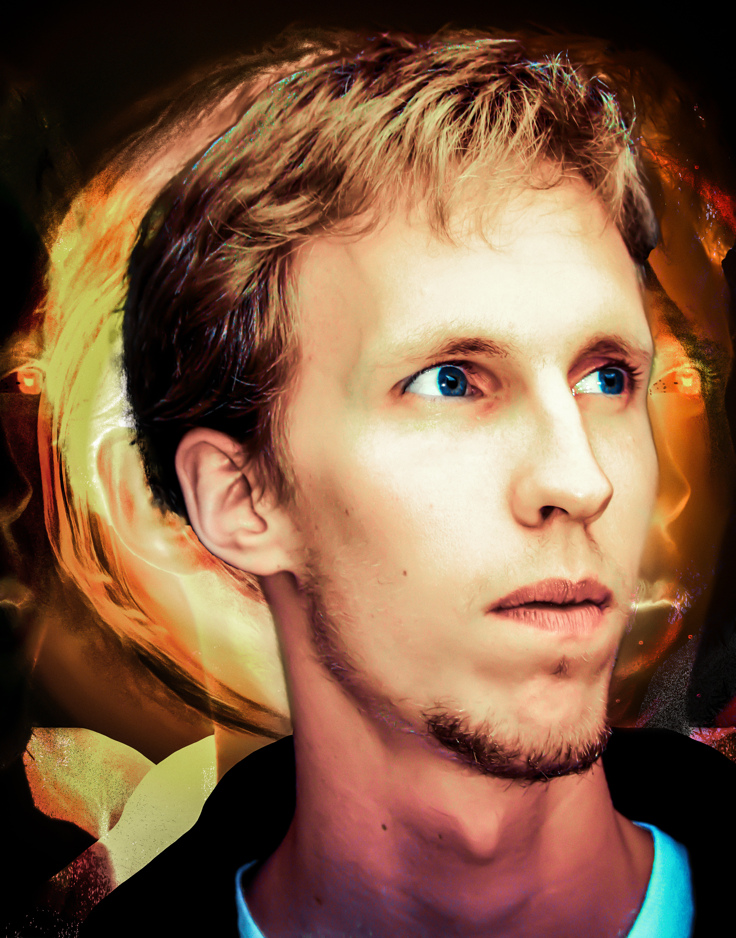
About Jocke Larsson
For Jocke Larsson, there has always been art. Even if he has tried his wings at acting and worked in other creative fields, art has always been an important outlet, a safe-space for his creativity and personal development.

From an early age, Jocke’s interest in photography became his starting point to capture the world around him. His mind observes and is drawn to the unexplainable, philosophical and abstract.

Nowadays, he naturally shifts between and combines the painted, digital, illustrated and photographed art, into his own multi-layered, expressionistic, storytelling style, aiming to evoke emotions that transcend boundaries.

Each stroke, each pixel, is a testament to the artist's innermost feelings, captured and immortalised in the form of NFTs and Fine Art Prints.

Born: Edsbro, Sweden (1985)

Exhibitions and book releases:

Östergötlands Länsmuseum, 2009, Sweden

“Uttryck Bortom Ungdomen” (Expressions Beyond Youth) a series of street photography portraits and a book with the same theme

