SUPERLUXE and ChessArt sign Art Partnership

SUPERLUXE & Partners, a Jersey-based Art Representation business and ChessArt, represented by inventor Matt Perchard, a Jersey-based Artist, have signed an Art Partnership Agreement that sees SUPERLUXE bring the ChessArt Collection exclusively to the global Print Art and Digital Art market.

Matt has developed a unique algorithm that takes every move from a game of Chess and turns it into a beautiful, personalised piece of art. An initial collection of ‘The Top 10 Games of All Time’ will be available as Limited Edition Artworks in editions of 100, followed by a personalised ChessArt artwork service, where players can upload their own game on the ChessArt.me website and create their own unique artwork.

The ‘The Top 10 Games of All Time’ Collection will form part of a multi-million pound fine art offering exclusively by SUPERLUXE and will be sold as Limited Edition Prints, Curtisium AROI Art Glass prints and Digital Art (NFTs), offering collectors and investors a unique opportunity to acquire a ChessArt artwork before the price increases. All formats will be marketed, sold and fulfilled through the SUPERLUXE.IO Fine Art Platform.

Speaking about the Art Partnership, artist Matt Perchard said “I am thrilled to be partnering with SUPERLUXE. James & his Team bring extensive experience in the UHNW and luxury brand space, as well as huge knowledge of how to market and sell Print and Digital Art to global collectors. I can’t wait to get started.”

James Matthewson, Founder & CEO at SUPERLUXE & Partners, also commented saying that “ChessArt is a thing of beauty, creating a unique and personal artwork for any chess fan. I first saw ChessArt a few months back and thought it an incredibly clever idea. We are over the moon that we have signed a globally exclusive Art Partnership Agreement with Matt & ChessArt, our second-only Jersey artist. We’re excited to bring this Collection of 10 curated artworks from the world of Chess to our clients around the world in both a Fine Art Print, Art Glass and Digital Art formats.”

SUPERLUXE & Partners (Jersey) and SUPERLUXE.io (BVI) is led by James A Matthewson, who brings 20+ years experience of working with some of the most prestigious luxury brands from across the globe.

James can be contacted on +44 7797 777507 or james@superluxe.art and will help Art Collectors and Investors, as well as Chess fans alike, with the purchase of their ChessArt from SUPERLUXE.

Notes to Editors:
Date of Release: 12th November 2024
Contact: James A Matthewson +44 7797 777507 / james@superluxe.art
Website: superluxe.io
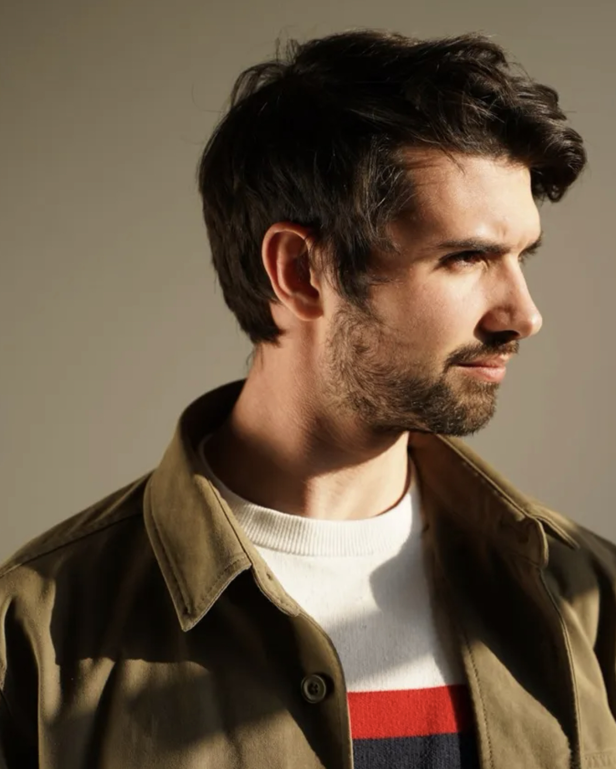
About ChessArt
ChessArt was founded by Matt Perchard, an obsessive, concept-driven creative. Matt has devoted his life to pushing the boundaries of artistic expression — from design and invention to movement and lighting. Matt has carved himself a creative portfolio like no other, designing across-disciplines all over the globe for renowned brands like BAFTA, the Oscars, Louis Vuitton and even being a creative lighting specialist for Tim Walker’s visionary fashion shoots.

Matt has always been a creative with an edge. But chess? That was an unexpected obsession. Becoming a tournament chess player in the London scene and travelling to places like Iceland to play in competitive formats, Matt became mesmerised by the game’s structure, history and people. He began to see each match as a potential artwork. This revelation sparked ChessArt, an innovative project translating each move of a chess game into expressive marks and lines. A pure representation of the raw creativity that two minds have when locked intensely in mental dance, movement and strategy.

Since its ideation in 2019, ChessArt has evolved to immortalise each chess game’s story in a single artwork. Every move is etched as a line, every line a memory, weaving a narrative that captures the beauty of chess and the intensity of human emotion. In ChessArt, art doesn’t just capture a game; it captures a moment in time.

