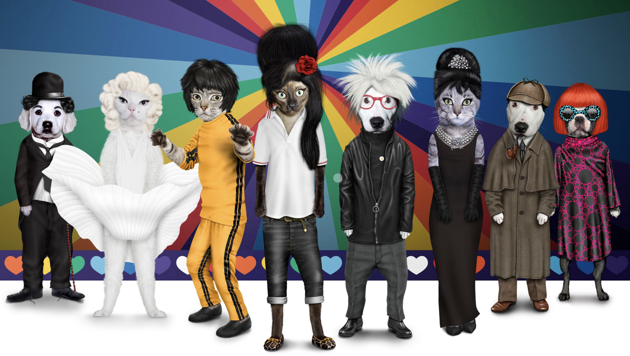SUPERLUXE and Pets Rock launch Brand Partnership

SUPERLUXE & Partners, a Jersey-based Luxury brand consultancy and Pets Rock, a London-based Fine Art Collectibles studio, today (21.02.23) have signed a Strategic Brand Partnership that sees SUPERLUXE take the Pets Rock collection to the global Art and NFT market.

Pets Rock is an extraordinary collection of instantly recognisable famous characters from the world of Pop Music to Politics, Royalty to Fashion, depicted as animals such as Dogs, Cats & Guinea Pigs. The collection of 80 Collectibles is a multi-million pound fine art collection and will be sold as NFTs for the first time, offering collectors and investors a unique opportunity to acquire their Pets Rock before price increases.

Collectors can enjoy choosing their Pets Rock (or Rocks) and each Collectible is accompanied by a unique, 1 of 1, Limited Edition A1 Artist Print as well as the NFT which will be marketed, sold and minted through the NINA Fine Art Tokenplace platform.

Speaking about the Brand Partnership, artist Mark Polyblank who created the Pets Rock series of characters back in 2008 and has been licensing the collection around the world ever since said “We are absolutely delighted to be partnering with SUPERLUXE. James brings extensive experience in the UHNW and luxury brand space, as well as huge knowledge of how to market and sell NFTs to global collectors. We can’t wait to get started.”

James Matthewson also commented saying that “since I first met Mark & Kate Polyblank during the summer of 2022, I absolutely loved the Pets Rock collection and wanted to be more involved. I’m over the moon that six months on we have signed a Brand Partnership Agreement and I can bring the Pets Rock Collection to my clients around the world in both a Fine Art and NFT format.”

Already, SUPERLUXE has sold 10 Pets Rock Collectibles to a client in their home market of Jersey, Channel Islands and has a queue of interest already forming in the characters. James believes each NFT drop of 5 characters at a time on NINA will sell out fast and as they do, the next drop will be at a higher price as the Collectibles become more scarce. He recommends readers of this press release act quickly.

SUPERLUXE & Partners in Jersey is spearheaded by James A Matthewson, who brings 20 years of working with some of the most prestigious luxury brands from across the globe, and is co-founder of IMPERIUM Magazine, a luxury digital magazine that reaches over 203,000 Readers every (bi-monthly) Edition.

James can be contacted on 07797 777507 or james@superluxe.je and will help Investors and Pets Rock / NFT fans alike with the purchase of their Pets Rock Fine Art and NFT from SUPERLUXE.

Notes to Editors:

Date of Launch: 21st February 2023
Contact: +44 7797 777507 james@superluxe.je
Website: pets-rock.com

About Pets Rock
Pets Rock is the creation of Mark and Kate Polyblank. Mark grew up surrounded by a variety of animals. He was an international still life photographer who gave it all up to draw cats in hats and dogs in wigs. Kate grew up on a farm and later became a commercial stylist and model maker. Now she manages the Pets Rock posse of pets.
Kate and Mark Polyblank set up their first design company Takkoda in 2005 launching a range of anthropomorphic pet characters that appeared on a collection of kids apparel and stationery. Their first customer was the British landmark store ‘Harrods’.
The old adage that ‘People look like their pets’ combined with their interest in pop culture, the global celebrity phenomenon and their love of animals led to the creation of Pets Rock in 2008.
Since then Pets Rock has grown into a range of over 80 characters. It’s won numerous awards, published 4 books, appeared on TV, been feted by celebrities, had exhibitions, featured in advertising campaigns, and collaborated with some amazing brands, retailers and designers.
But most importantly Pets Rock has spread joy and made a lot of people smile….

